ACM task

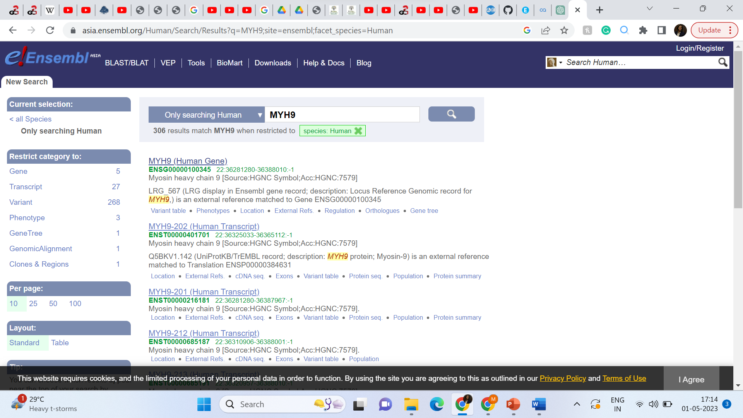

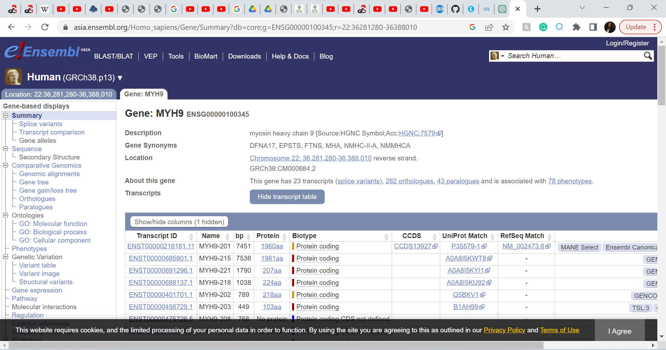

MYH9 is located on chromosome 22, the minus strand ([Chromosome 22: 36,281,280-36,388,010](https://asia.ensembl.org/Homo_sapiens/Location/View?db=core;g=ENSG00000100345;r=22:36281280-36388010) reverse strand).

The gene has 23 transcripts (splice variants). I went for the canonical transcript, ENST00000216181.11. The length of protein it encodes is 160 amino acids.

The particular transcript I want to analyse will depend on what exactly my research question is. This seems to be more general-purpose, so I’m going for the canonical transcript. That is the most conserved, most highly expressed, has longest coding sequence and is usually the reference transcript.

If there was something more specific, I would have chosen a transcript accordingly. For example, [ENST00000401701.1](https://asia.ensembl.org/Homo_sapiens/Transcript/Summary?db=core;g=ENSG00000100345;r=22:36281280-36388010;t=ENST00000401701) was checked out to study macrothrombocytopenia.

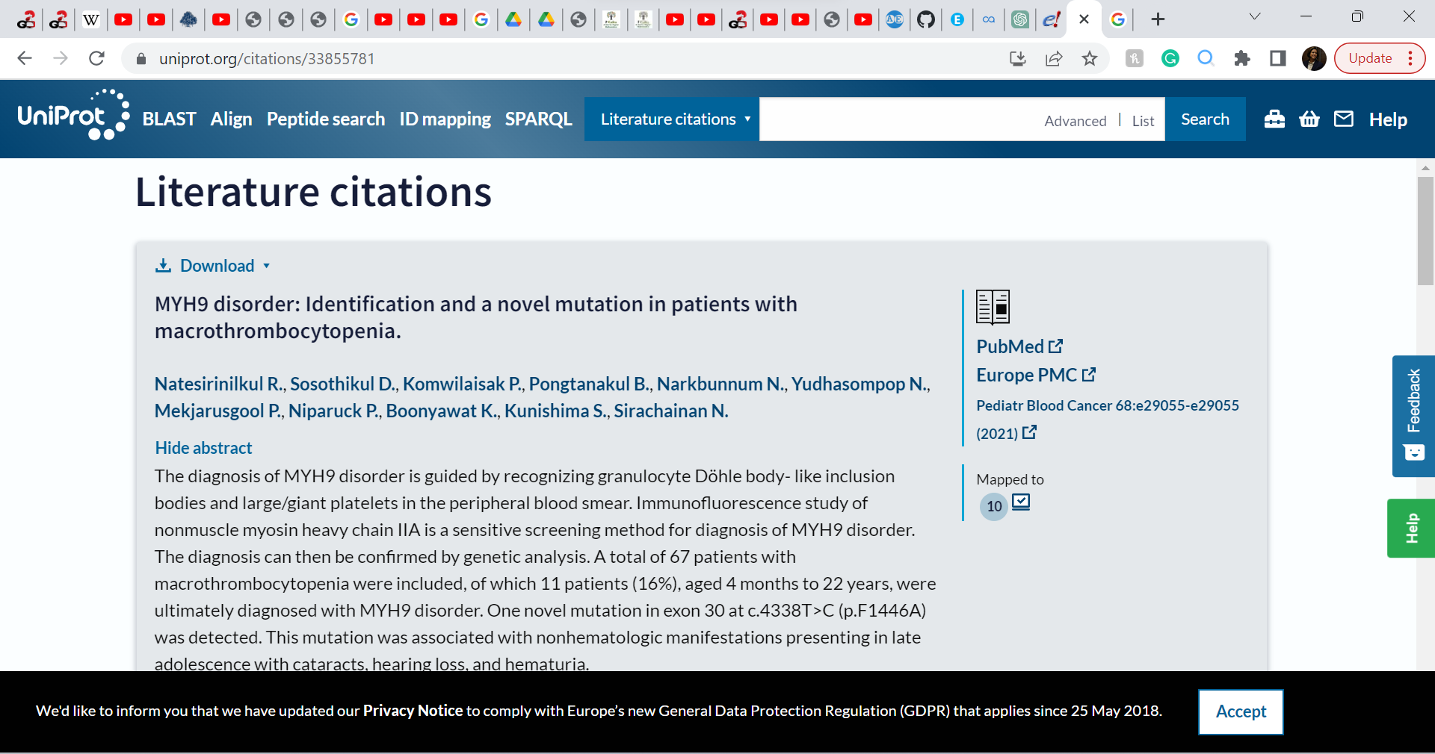

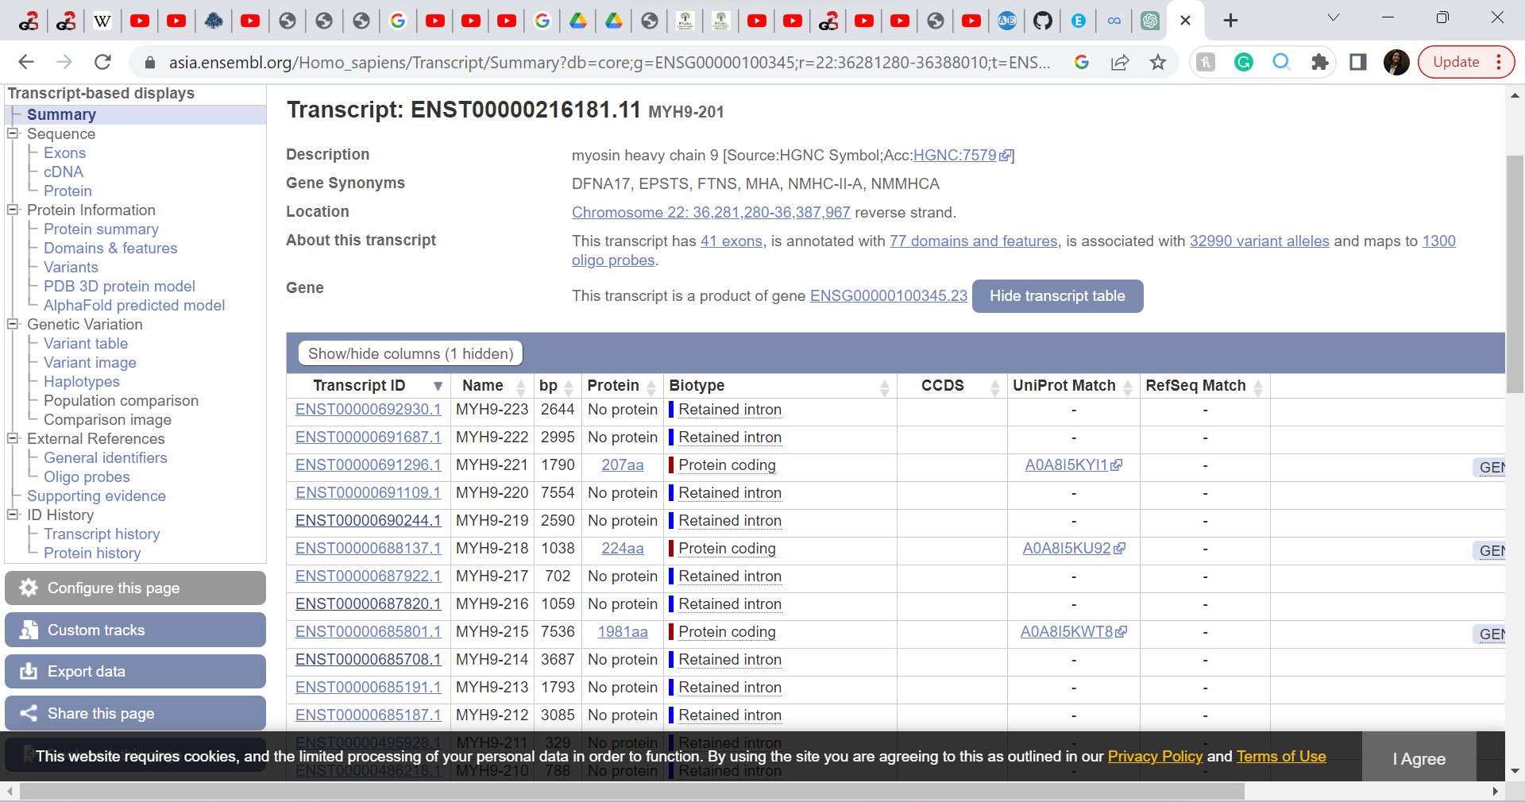

I went to the Uniprot link to check the protein length

